**Project Report**

**on**

**D.E.X.T.E.R**



**Submitted By**

VINAAYAK SRIVASTAVA

KAUSTUBH SETHI

Class: XI D

**Under the Guidance of**

Ms. Angel Panesar

Department of Computer Science

Sardar Patel Vidyalaya

Lodhi Estate, New Delhi 110003

**CERTIFICATE**

This is to certify that Vinaayak Srivastava and Kaustubh Sethi Of Class XI D have prepared the report on the Project entitled “D.E.X.T.E.R”. The report is the result of their efforts & endeavors. The report is found worthy of acceptance as final project report for the subject Computer Science of Class XI. They have prepared the report under my guidance.

Ms. Angel Panesar

Department of Computer Science

Sardar Patel Vidyalaya

Lodhi Estate, New Delhi 110003

**DECLARATION**

We hereby declare that the project work entitled “D.E.X.T.E.R”, submitted to Department of Computer Science, Sardar Patel Vidyalaya,Lodhi Estate, New Delhi 110003is prepared by us. The project work is result of our personal efforts.

Vinaayak Srivastava

Kaustubh Sethi

Class: XI D

**ACKNOWLEDGEMENT**

/WRITE YOURSELF/

Vinaayak Srivastava

Kaustubh Sethi

Class: XI D

**CONTENTS**

|  |  |  |
| --- | --- | --- |
| S. No. | Topic | Page No. |
| 1. | LIBRARIES USED | 6 |
| 2. | WORKING DESCRIPTION | 7-9 |
| 3. | PROJECT CODE | 10-18 |
| 4. | OUTPUT SCREENS | 19-21 |
| 5. | CONCLUSION | 22 |
| 6. | BIBLIOGRAPHY | 23 |

**LIBRARIES USED**

* webbrowser
* numpy as np
* cv2
* random
* playsound
* time
* wikipedia
* math
* speech_recognition as sr
* sys

**WORKING DESCRIPTION**

* This project comprises of many features for user as an assistant it can the user with basic definition of words ,it can set a timer or a stopwatch it can play music, display memes and has a small game to pass time. And calculator to ease your work
* The speech recognition is by
* The flow of the project is it takes a text from user via speech recognition or a text input then converts it to lower case and if the text is key word to one of are many function it executes it and if not found it searches for it on the Google chrome in a new tab with that text searched
* One of our functions is web pages made by us on Google new sites of facts of many subjects like physics, biology, and astronomy, animal and many more with the help of webbrowser library with opens a url on chrome on a new tab which can be by user to read some facts and gain some knowledge
* We used playsound library to play music for user for entertainment/relaxation the library has to given the path of the file in order to play the music it has total of 3 songs right now and it plays randomly by random.randomchoice which selected the file name and plays songs randomly when in use
* We have used time for making stopwatch and timer. The stopwatch is made by time sleep set to 1 and starts from 0 till ctrl +c not entered. timer takes input of number of hours, minutes and seconds in order to start the program
* We used cv2 and numpy to display memes for entertainment/relaxation or to just pass time it uses the path of image to be shown and image generated is random by randomchoice
* We made odd eve a game with simple if statements and random.randint in which user has a option to take batting or bowling and then you pick number between 0 and 11 in order to make runs and if same number is generated by computer and the number enter by user is same then the batting player is out
* We added word a day pages made by us on Google new sites which helps in improving our vocabulary which opened by webbrowser with the given url
* Wikipedia is an API library which helps to connect with Wikipedia in order to get summary of that definition number of sentences can be set which we have set to 2 it can be used to search for simple and short answers to your questions
* If the word is not on Wikipedia then it will open a Chrome page with the word already searched by webbrowser
* The features of this Calculator are as follows:-
* It can do basic arithmetic operations like Division, Multiplication, Addition and Subtraction only one operation at a time.
* .It can calculate any power of a given float and can also calculate squares, squareroots, cubes, cuberoots of the given number.

The Calculator in addition to all of the above mentioned functions can also calculate the value of some of the Trigonometric funtions like sine, cosine, tangent etc. by the USE OF MATH MODULE functions like math.sin(<angle>) or math.tan(<angle>)

It can also calculate the log or antilog of a given number but only to the base 10

The basic idea behind the funtioning of this Calculator is that :

* First, it takes a string input from the user either through keyboard or through speech recognition.
* It then seperates the words of the list by the function l.split( )
* It has a long list of various keywords present inside the program.
* Then it searches for some specific keywords in the list of the input.
* If it finds those keywords in the input then it is directed inside the if statement, else it asks the user again what mathematical operation they want to perform
* Inside the if statement, there are various possibilities of the keyword which in turn direct the program to run accordingly.

Thus this Calculator uses a very interesting way of interacting with the user and asking them about the mathematical operations they want(it uses text as input from the user).

This program was a great way of expanding our knowledge about the MATH MODULE and learning about the various functions it has.

We can surely develop on this Calculator in future and make it more user friendly and efficient. It can be modified in many ways.

This was an excellent learning experience for both of us in the field of python and computer science.

**PROJECT CODE**

Main loop-

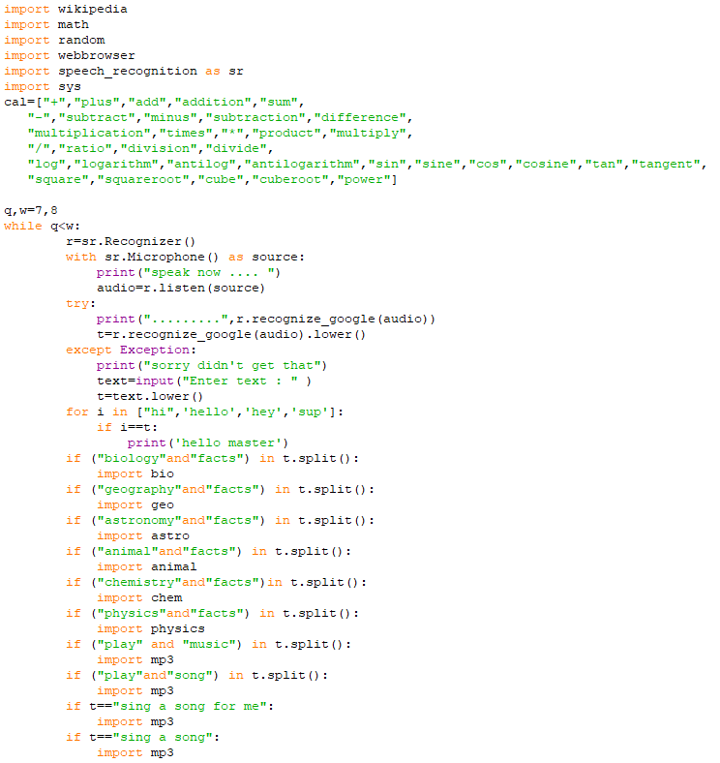

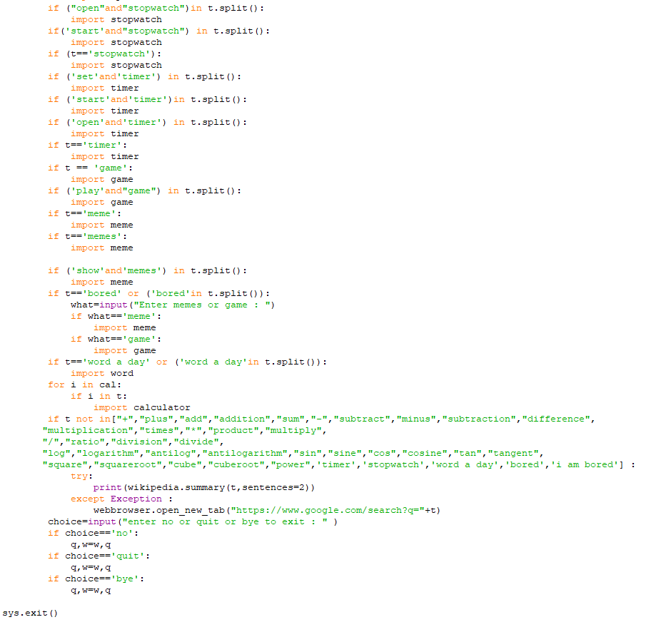

Import bio



Import geo



Import astro



Import animal



Import chem.



Import physics



Import mp3

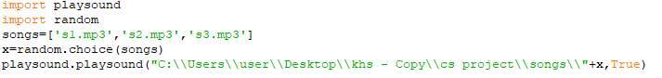

­import stopwatch

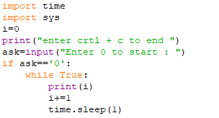

Import timer

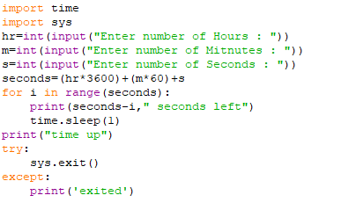

Import game

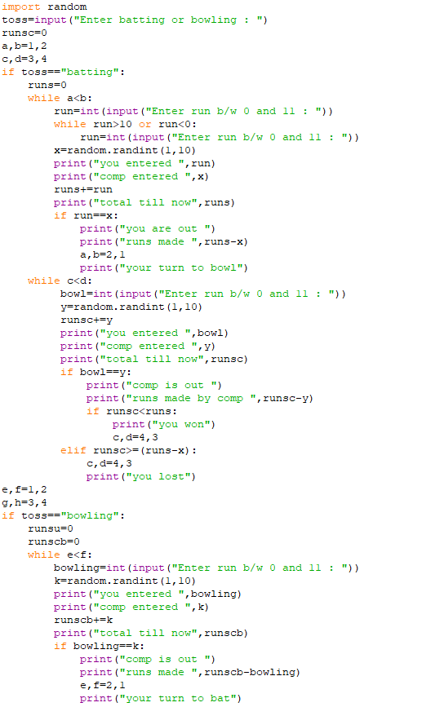

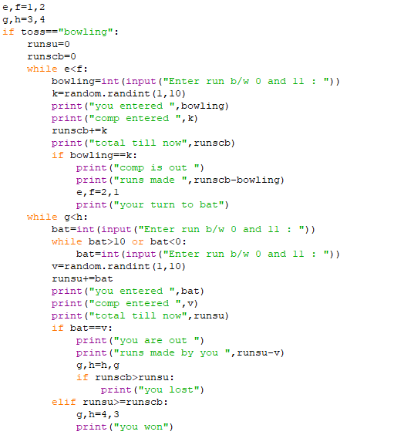

Import meme

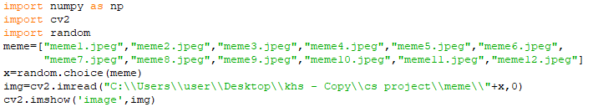

Import word



Import calculator

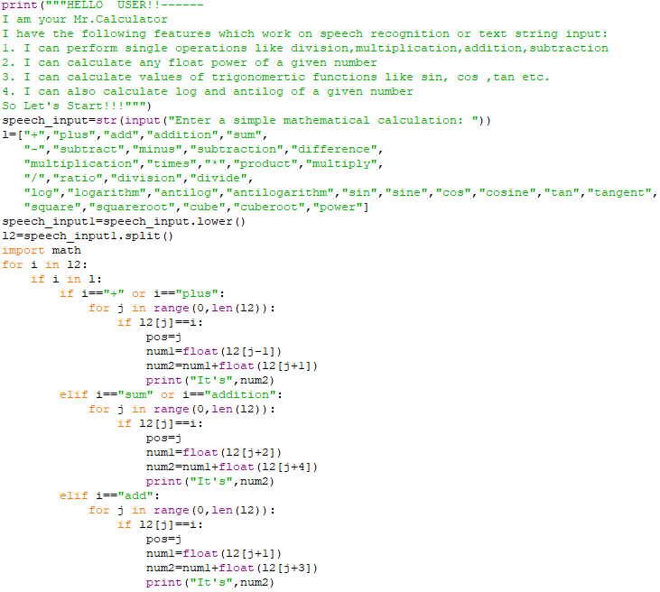

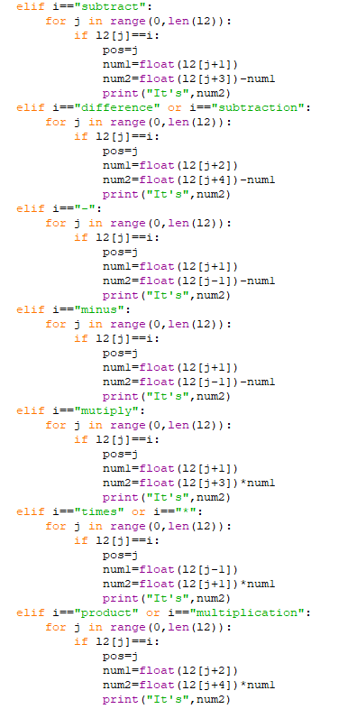

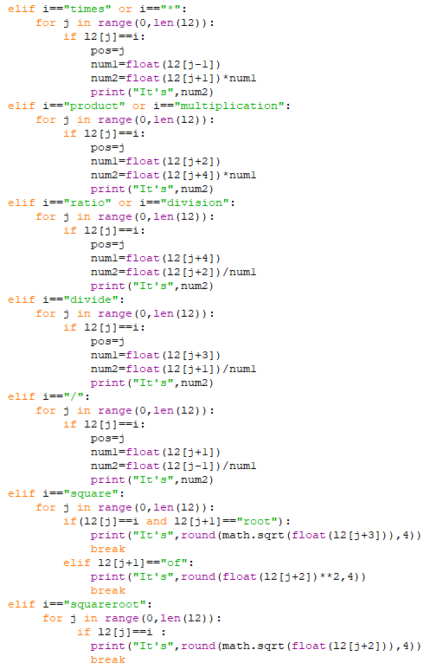

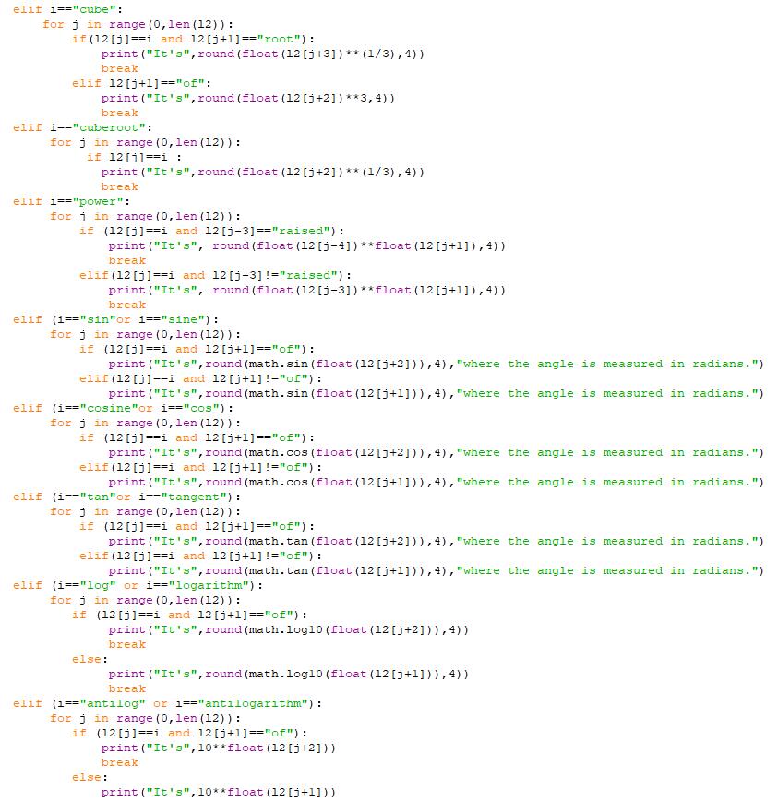

**OUTPUT SCREENS**

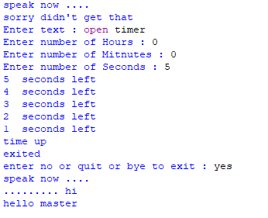

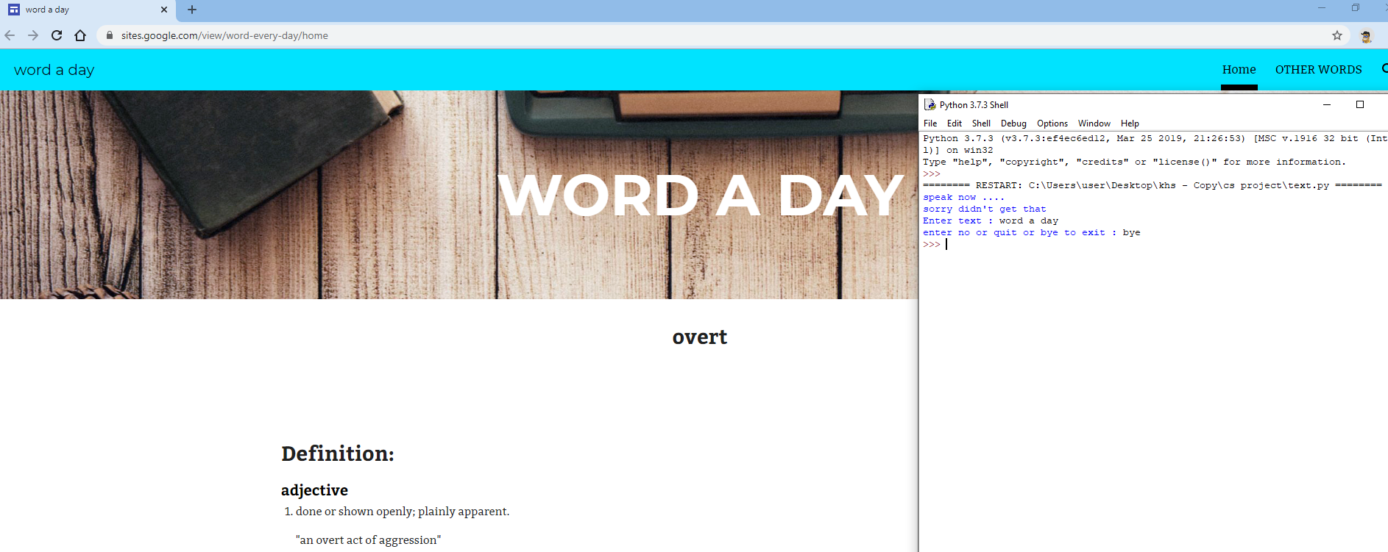

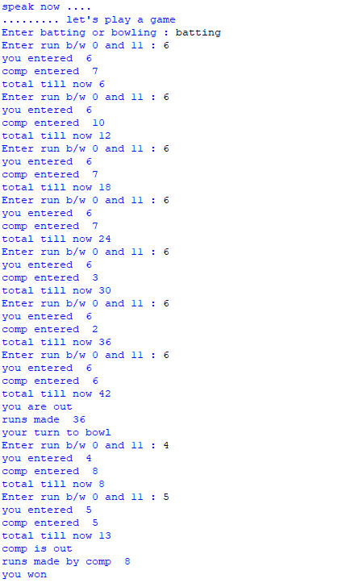

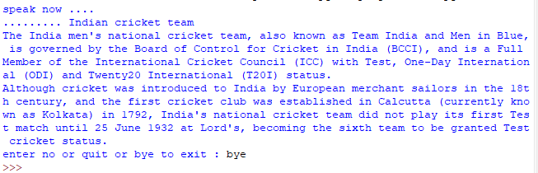

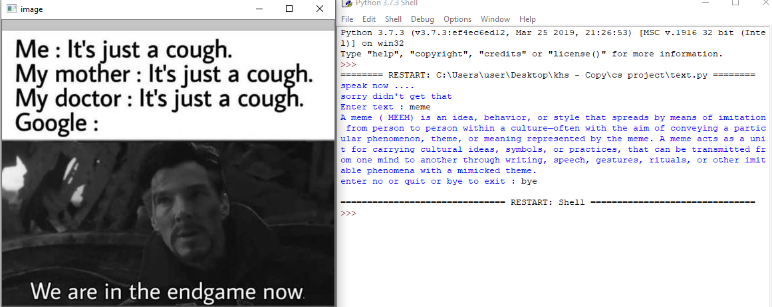

**CONCLUSION**

The project can be used to get basic assistance like timer, stopwatch, and music

Via speech recognition or text input which is user friendly and the further development that can be done in this project is adding more sites API to gather information from many sites and provide to user at one place. Making speech recognition would be the second goal this project can get people basic definition of words/concepts from all around in one widow.

You can play a basic gave when you are bored or see memes or listen to music. You can use log , antilog or even trigonometric ratio values of all angles and make you work much easier the word a day site can help you improve your vocabulary and the facts of many subjects can help you gain some knowledge.

**BIBLIOGRAPHY**

1. Sumita Arora, *Computer Science with Python*, 2019
2. <https://www.mediawiki.org/wiki/API:Client_code>
3. <https://docs.python.org/2/library/webbrowser.html>
4. <https://www.kdnuggets.com/2019/07/practical-speech-recognition-python-basics.html>
5. <https://pythonbasics.org/python-play-sound/>
6. <https://data-flair.training/blogs/opencv-python-tutorial/>